Pears:

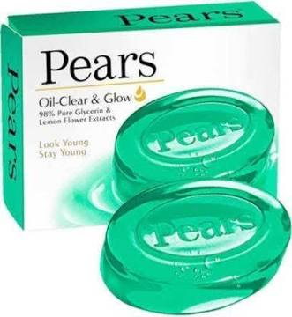

The goals and objectives of the Pears soap brand may evolve over time, but as of my last knowledge update in September 2021, some of their typical goals and objectives in the personal care industry could include:

Market Leadership: To maintain or achieve a leadership position in the market for transparent glycerin-based soaps.

Brand Recognition: To enhance brand awareness and recognition among consumers, both locally and internationally.

Product Innovation: To continually innovate and develop new soap variants or related products that cater to changing consumer preferences.

Quality Assurance: To maintain high standards of quality and safety in their products to meet consumer expectations and regulatory requirements.

Customer Satisfaction: To ensure high levels of customer satisfaction through effective customer service and by delivering products that meet their needs.

Sustainability: To align with sustainability goals by adopting environmentally friendly practices in production and packaging.

Market Expansion: To explore opportunities for expanding their market reach, whether by entering new geographical markets or targeting new customer segments.

Profitability: To achieve and maintain a healthy level of profitability for sustained business growth.

Key Performance Indicators (KPIs) for a brand like Pears Soap can vary depending on their specific business goals and strategies. However, here are five potential KPIs that a brand like Pears Soap might consider:

Sales Revenue: Tracking the total revenue generated from the sale of Pears Soap products is a fundamental KPI to measure the brand’s financial performance.

Market Share: Measuring the brand’s market share within the soap and skincare industry can provide insights into its competitive position.

Customer Satisfaction: Monitoring customer satisfaction through surveys, reviews, and feedback can help gauge the brand’s popularity and customer loyalty.

Brand Awareness: Tracking brand awareness metrics, such as brand recognition and recall, can indicate the effectiveness of marketing and advertising efforts.

Social Media Engagement: Measuring social media metrics like likes, shares, comments, and follower growth can reflect the brand’s online presence and engagement with its audience.

It’s essential for Pears Soap or any brand to align KPIs with their specific objectives and regularly review and adapt them as needed to stay competitive and meet business goals.

Description:

These KPIs should align with Pears Soap’s specific business goals and market conditions. Regularly reviewing and adapting these indicators can help the brand make informed decisions to improve its performance and maintain or grow its market presenceThese objectives may have evolved or been refined since my last update, so it’s advisable to check the latest information from the brand for their current goals and objectives.

Toyota:

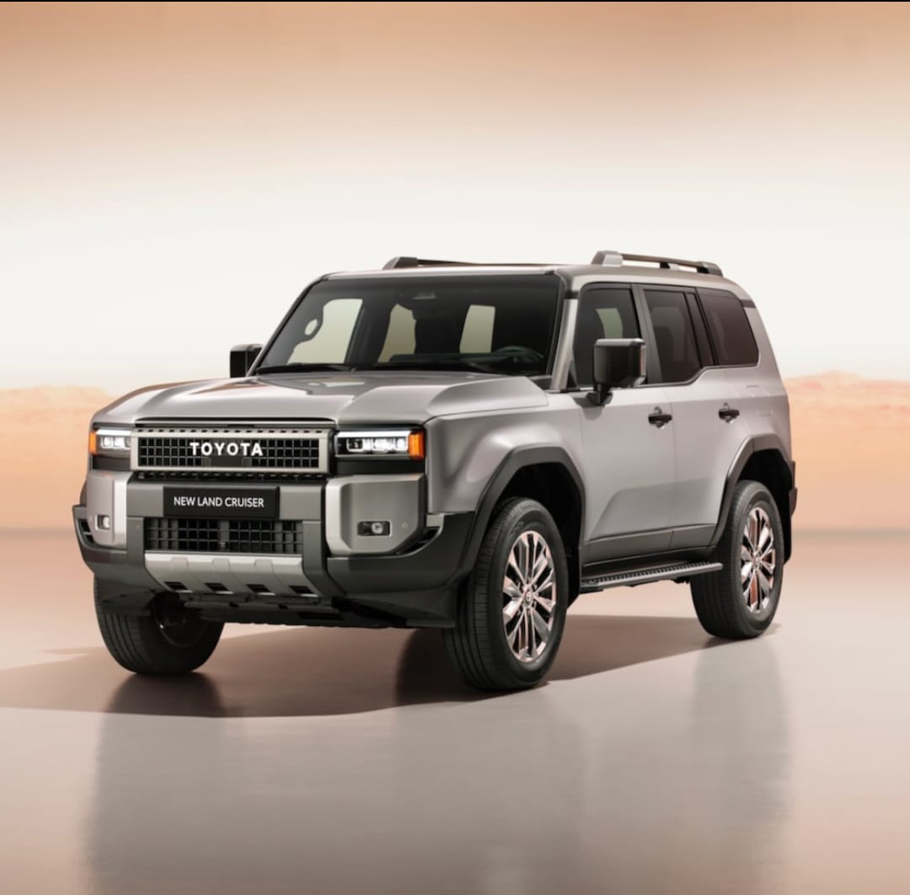

Toyota, as a car brand, has several overarching goals that have been consistent throughout its history:

Quality and Reliability: Toyota is known for its commitment to producing high-quality, reliable vehicles. Their goal is to build cars that last and provide value to their customers.

Innovation: Toyota aims to be at the forefront of automotive innovation. This includes advancements in technology, safety features, and environmentally-friendly vehicles like hybrid and electric cars.

Sustainability: Toyota has a strong focus on sustainability. Their goal is to reduce the environmental impact of their vehicles and operations. They were pioneers in popularizing hybrid technology with the Prius and continue to invest in eco-friendly technologies.

Customer Satisfaction: Customer satisfaction is a top priority for Toyota. They aim to provide excellent customer service and produce vehicles that meet the needs and preferences of their customers.

Global Expansion: Toyota is a global brand, and they have a goal of expanding their presence in different markets around the world. This includes both developed and emerging markets.

Safety: Safety is a fundamental goal for Toyota. They are committed to producing vehicles with advanced safety features and technologies to protect both drivers and pedestrians.

Profitability: Like any business, Toyota aims to be profitable. This allows them to invest in research and development, innovation, and sustainability initiatives.

Continuous Improvement: Toyota has a culture of continuous improvement, often referred to as the Toyota Production System (TPS). They seek to improve efficiency, reduce waste, and optimize their manufacturing and business processes.

Key Performance Indicators (KPIs) for the Toyota car brand can vary depending on specific goals and strategies, but here are five important KPIs that are commonly tracked in the automotive industry:

Sales Volume: The number of Toyota vehicles sold is a fundamental KPI. It indicates the brand's market share and overall performance in terms of customer demand.

Market Share: Toyota's market share in various regions or segments is a critical KPI. It reflects the brand's competitive position compared to other automakers.

Customer Satisfaction: Measuring customer satisfaction through surveys and feedback is essential. High satisfaction scores indicate product quality and customer loyalty.

Quality Metrics: Tracking quality-related KPIs, such as defect rates, recalls, and warranty claims, is crucial for ensuring product reliability and reducing costs associated with quality issues.

Environmental Impact: Given the industry's increasing focus on sustainability, tracking KPIs related to emissions, fuel efficiency, and the adoption of electric and hybrid vehicles is important for Toyota's brand image and compliance with environmental regulations.

Description:

These become one of the largest and most successful automotive companies globally, known for its quality, innovation, and commitment to sustainability.Thesenitor its performance, identify areas for improvement, and make strategic decisions to maintain its position in the automotive market.

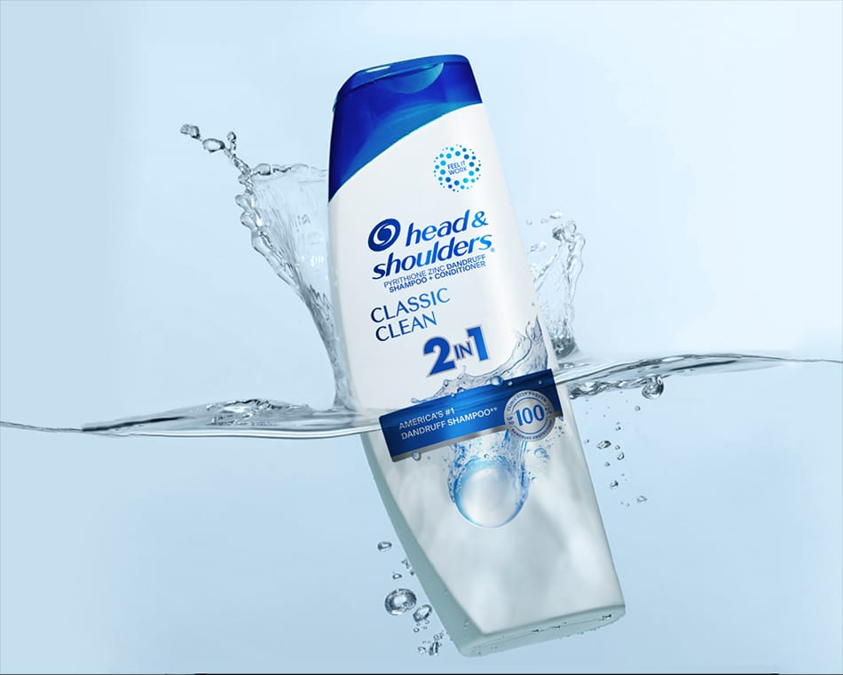 Head & Shoulders:

As of my last knowledge update in September 2021, Head & Shoulders, a popular shampoo brand, typically had the following goals and objectives:

\*\*Dandruff Control\*\*: One of its primary objectives is to provide effective dandruff control and relief to its consumers. The brand aims to develop and market shampoos that effectively combat dandruff, flakes, and scalp itchiness.

\*\*Healthy Scalp and Hair\*\*: Head & Shoulders also focuses on promoting overall scalp and hair health. Their products often include ingredients to nourish and strengthen the hair, in addition to controlling dandruff.

\*\*Brand Awareness\*\*: Building and maintaining strong brand awareness is crucial for consumer product companies. Head & Shoulders aims to ensure that consumers recognize and trust their brand for dandruff control and hair care.

\*\*Market Share Growth\*\*: Like any consumer product, the brand likely seeks to increase its market share by appealing to a wider audience and outperforming competitors in the hair care industry.

\*\*Innovation\*\*: Continuous innovation in product formulation and packaging is essential to meet evolving consumer preferences and stay competitive in the market.

\*\*Sustainability\*\*: In recent years, many consumer brands, including those in the personal care industry, have also focused on sustainability goals. This might include reducing their environmental footprint, using recyclable packaging, or sourcing ingredients responsibly.

\*\*Global Expansion\*\*: Head & Shoulders, being a globally recognized brand, may have objectives related to expanding its reach to new markets and regions.

Key Performance Indicators (KPIs) for a Head & Shoulders shampoo brand might include:

\*\*Sales Revenue\*\*: Measuring the overall revenue generated by the brand is crucial to assess its financial performance.

\*\*Market Share\*\*: Tracking the brand’s market share within the shampoo industry helps gauge its competitiveness and growth potential.

\*\*Customer Satisfaction\*\*: Monitoring customer satisfaction through surveys or feedback can provide insights into the product’s effectiveness and customer loyalty.

\*\*Brand Awareness\*\*: Assessing the brand’s recognition and awareness levels in the market can help evaluate marketing and advertising efforts.

\*\*Repeat Purchase Rate\*\*: Calculating how often customers repurchase Head & Shoulders shampoo can indicate brand loyalty and product satisfaction.

Description:

These KPIs can provide a comprehensive view of the brand’s performance in terms of sales, market presence, customer satisfaction, and loyalty. However, specific KPIs may vary depending on the brand’s goals and strategies.Goals and objectives can evolve over time, so it’s possible that Head & Shoulders may have adapted or added new objectives since my last update in September 2021. For the most up-to-date information, I recommend visiting the official website of the brand or checking recent corporate reports and news articles.

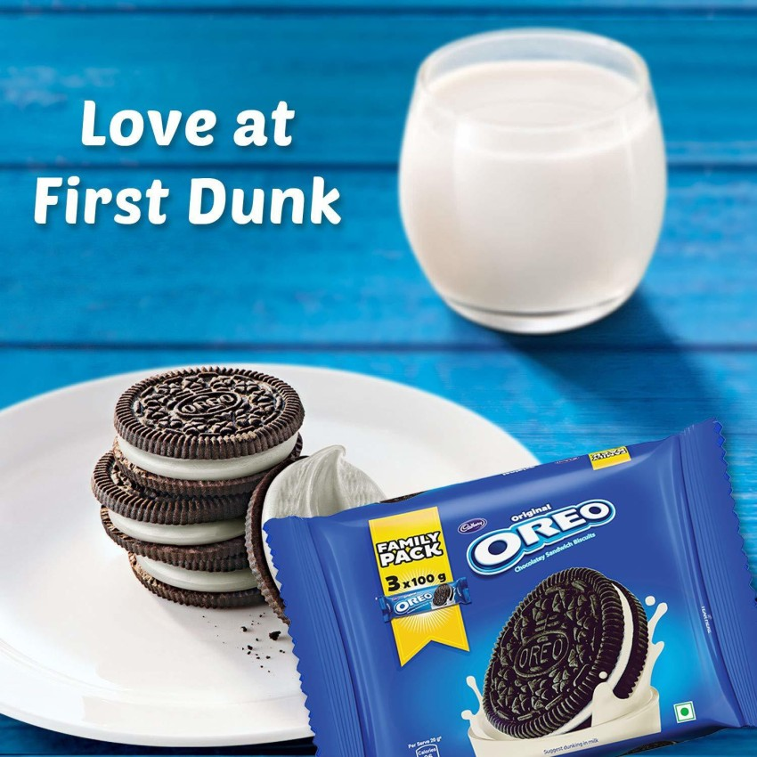Oreo :

The goals of Oreo biscuits, like any consumer product, typically revolve around satisfying customer preferences and generating profit for the manufacturer. Some common goals for Oreo biscuits might include:

Taste and Quality: To consistently deliver a delicious and high-quality cookie that meets consumer expectations.

Brand Recognition: To maintain and strengthen the Oreo brand as a trusted and beloved snack.

Innovation: To introduce new flavors, varieties, or limited-time offerings to keep consumers engaged and interested.

Market Share: To compete effectively in the cookie and snack market and gain or maintain a significant share of the market.

Profitability: To generate revenue and profit for the manufacturer and its shareholders.

Sustainability: To reduce the environmental impact of production and packaging, aligning with sustainability goals.

Consumer Satisfaction: To ensure consumers are satisfied with their Oreo experience and keep coming back for more.

Key Performance Indicators (KPIs) for a brand like Oreo biscuits can vary depending on their specific business goals and strategies. However, here are five possible KPIs that Oreo or a similar brand might track:

\*\*Sales Revenue:\*\* Monitoring the overall sales revenue is a fundamental KPI for any consumer product brand, including Oreo. It reflects the brand’s market performance and growth.

\*\*Market Share:\*\* Measuring the brand’s market share in the cookie and biscuit industry helps assess its competitive position and market dominance.

\*\*Brand Awareness:\*\* Tracking brand awareness metrics such as brand recall and recognition can indicate how well Oreo is known among its target audience.

\*\*Customer Satisfaction:\*\* Gathering feedback from customers and monitoring customer satisfaction scores can provide insights into product quality and customer loyalty.

\*\*Social Media Engagement:\*\* Given the importance of digital marketing, tracking social media KPIs like follower growth, engagement rates, and sentiment analysis can gauge the brand’s online presence and customer engagement.

Description:

Keep in mind that these KPIs can change over time and may vary based on the brand’s specific objectives and market conditions.These goals may evolve over time in response to changing consumer preferences, market trends, and societal concerns.

Honda:

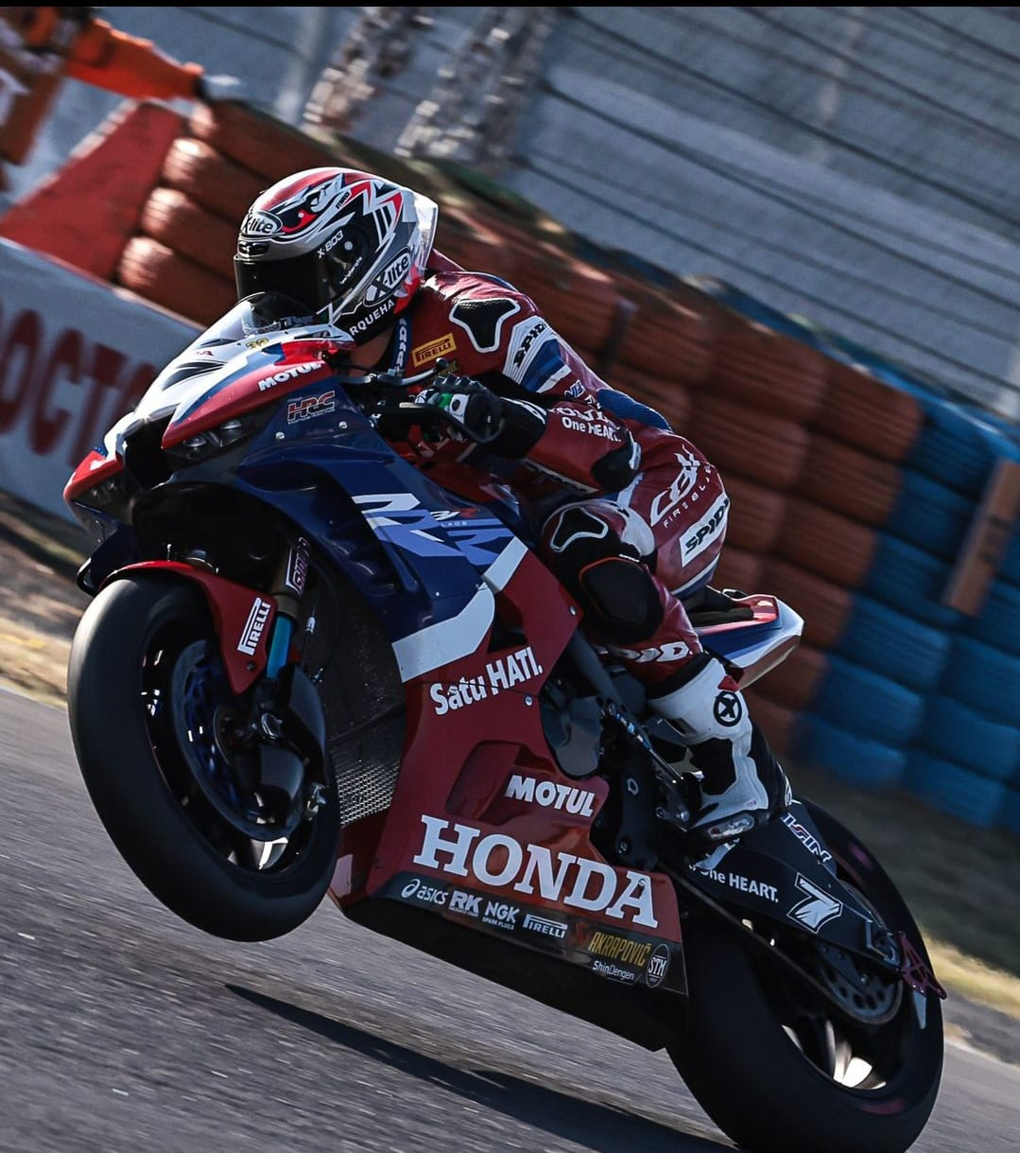

Honda, as a motorcycle manufacturer, typically has overarching goals and objectives that align with its mission and vision for producing motorcycles. While these goals and objectives can evolve over time, here are some common ones:

\*\*Quality and Reliability\*\*: Honda aims to produce motorcycles that are known for their high quality and reliability. They strive to build bikes that can withstand various conditions and provide a trouble-free riding experience.

\*\*Innovation\*\*: Honda is often at the forefront of motorcycle innovation. They aim to introduce new technologies and features in their bikes to enhance performance, safety, and rider comfort.

\*\*Safety\*\*: Ensuring the safety of riders is a top priority. Honda works on implementing safety features and designs in their motorcycles to reduce accidents and injuries.

\*\*Environmental Responsibility\*\*: Honda is committed to reducing the environmental impact of their motorcycles. They set objectives to improve fuel efficiency, reduce emissions, and explore alternative energy sources like electric motorcycles.

\*\*Customer Satisfaction\*\*: Customer satisfaction is a key goal for Honda. They aim to meet and exceed customer expectations through their products and services, providing excellent customer support and addressing any issues promptly.

\*\*Global Expansion\*\*: Honda seeks to expand its presence in various markets around the world. This involves setting objectives for market share and sales growth in different regions.

\*\*Inclusivity\*\*: Honda may have goals related to making their motorcycles accessible to a wide range of riders, including those with disabilities or different riding preferences.

\*\*Community Engagement\*\*: Some objectives may involve community engagement and corporate social responsibility, such as supporting local communities and promoting motorcycle safety.

Key Performance Indicators (KPIs) for evaluating the performance of the Honda bike brand may include:

\*\*Sales Volume\*\*: Tracking the number of Honda bikes sold over a specific period is a fundamental KPI to measure brand success.

\*\*Market Share\*\*: Calculating the percentage of the motorcycle market that Honda holds can provide insights into its competitiveness.

\*\*Customer Satisfaction\*\*: Measuring customer satisfaction through surveys or feedback can gauge the brand’s reputation and customer loyalty.

\*\*Maintenance and Reliability\*\*: Monitoring the frequency of repairs and warranty claims can indicate the quality and reliability of Honda bikes.

\*\*Online Presence\*\*: Evaluating the brand’s online presence, including social media engagement, website traffic, and online reviews, can reflect its digital marketing effectiveness and customer engagement.

Description:

These KPIs can help Honda assess its brand’s performance, identify areas for improvement, and make informed business decisions.It’s important to note that the specific goals and objectives of Honda motorcycles can vary by region and market segment. They adapt their strategies to meet the unique demands and preferences of different customer groups.